3.4.2 Number of awards and recognitions received for extension activities from government/ government recognized bodies during the year
NAME OF THE AWARD | DETAIL
HMV GOT ASSOCHAM INSTITUTE OF THE YEAR AWARD FOR MULTIMEDIA AND ANIMATION | Hans Raj Mahila Maha Vidyalaya, the premier institute of North India has been awarded with the prestigious ASSOCHAM Education Excellence Institute of the year Award for Multimedia and Animation. The award is aimed at recognizing the excellent contribution of the institution in fostering affordable quality education and taking initiatives for nurturing an atmosphere of excellence  The award was presented by Sh. Vinay Prabhakar Sahasrabuddhe, Member of Parliament, President, Indian Council for Cultural Relations to Principal Prof. Dr. (Mrs.) Ajay Sareen. The award was bestowed during 14th National Education Summit & Annual Excellence Award 2021 on NEP 2020 – Transforming Educational Landscape of the Nation and carving a Road Map for Implementation. | 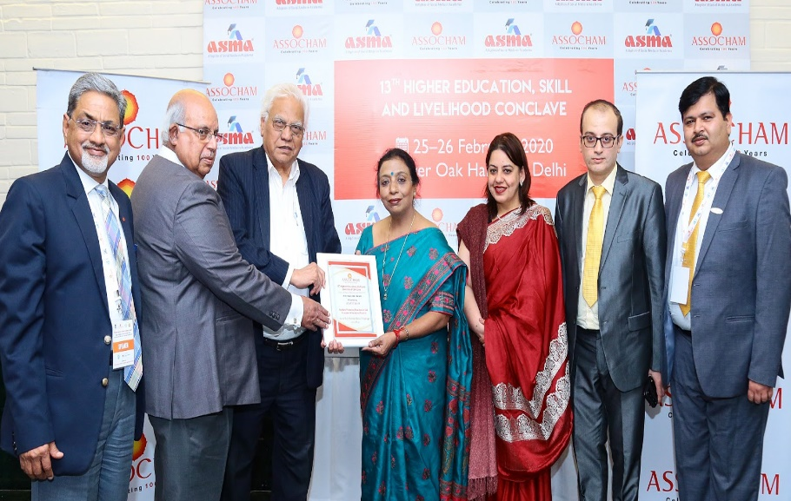  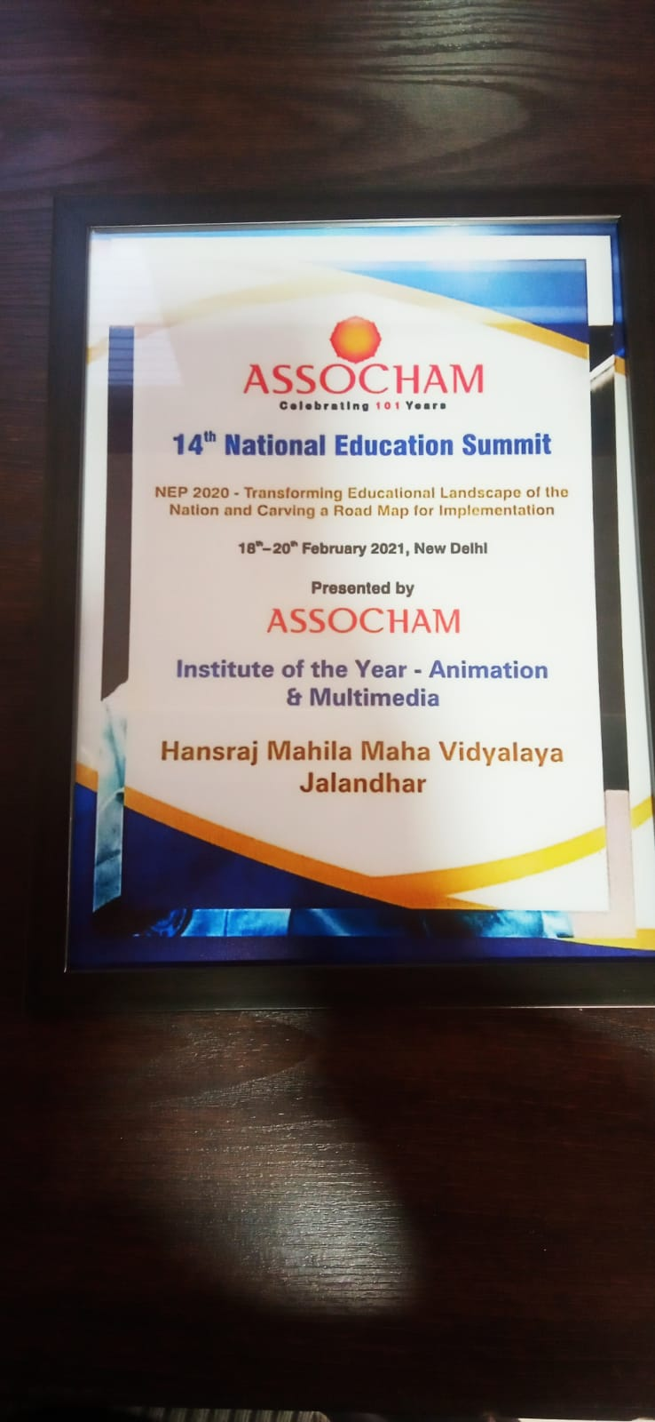
HMV DECLARED AS GREEN CHAMPION BY MINISTRY OF EDUCATION | Hans Raj Mahila Maha Vidyalaya, Jalandhar has been declared as Green Champion by Department of Higher Education, Ministry of Education, Govt of India. About 1000 higher educational institutions participated in the Mahatma Gandhi National Council of Rural Education "One District One Green Champion" awards organized by MGNCRE as per the directive of the Ministry of Education for Contribution to Swachhta Education and Practice under Swachhta Action Plan 2020-2021 which is a Swachh Bharat initiative of the honourable Prime Minister of India. These awards are based on sustainability audit focusing on campus greenery, cleanliness and maintenance, toilet adequacy in campus, tree planting and community outreach in promoting Swachh culture.Principal Prof. Dr. (Mrs.) Ajay Sareen said that the mission of Hans Raj Mahila Maha Vidyalaya, Jalandhar is to provide Value Oriented, Skill Based and Globally Competent Education in sync with Nation's March towards Sustainable Growth and Prosperity. | 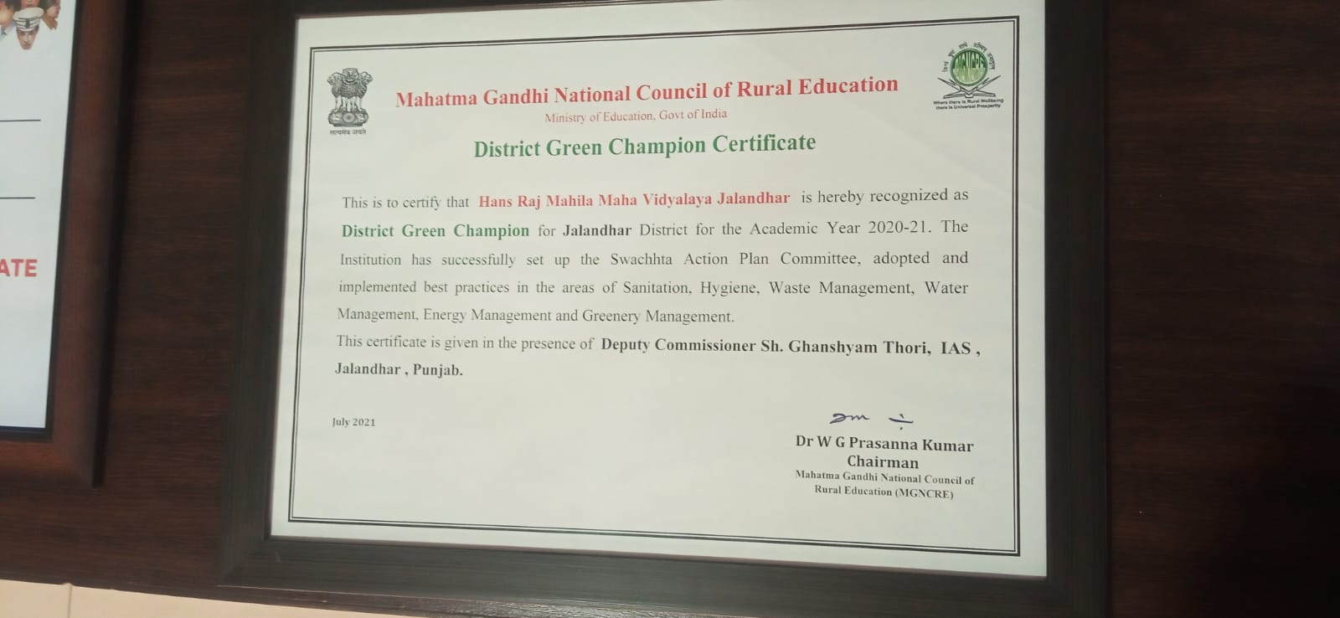
CLEAN SWEEP OF HMV IN SPRING FEST OF GNDU | Hans Raj Mahila Maha Vidyalaya, Jalandhar bagged Overall Trophy in Spring Festival of flowers, Plants & Rangoli held at GNDU Amritsar from 17th to 19th March Spring event was organised by Department of Landscaping & Department of Botanical & Environment Sciences, GNDU, Amritsar. The event had 394 entries from various colleges affiliated to GNDU, local schools & nurseries. HMV bagged 3 first prizes in categories A6, B4, B6 which include stock salvia, Dracaena & ficus and 8 second prizes (B8, B7, B2, B1, A7, A3, A2) in categories A2, A3, A7 (Dahlia Marigold, Gazania) B1, B2, B7 & B8, B9 (Aglonema, Crotons, Palms, Ficus & Ornamental Plants). | 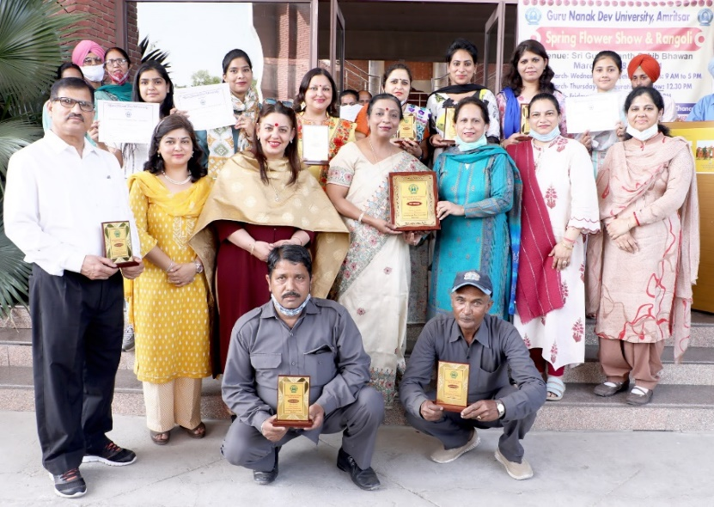  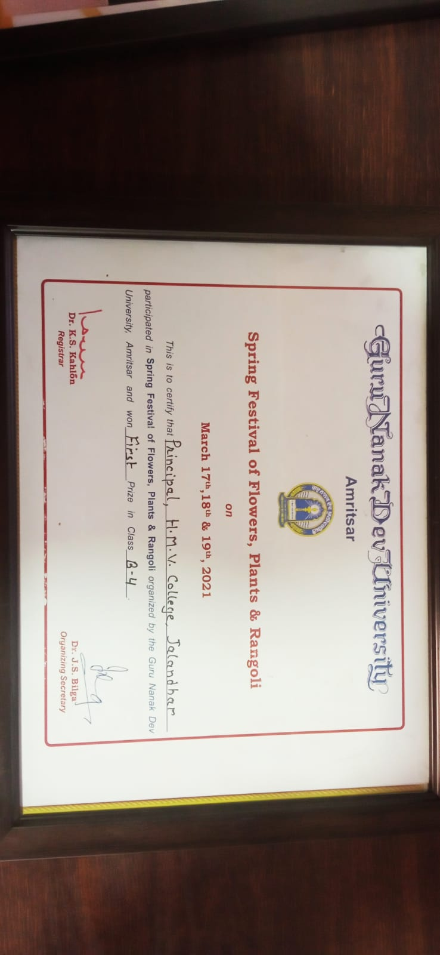
HMV DECLARED AS BEST COLLEGE IN NCC ACTIVITIES 2020 | Hans Raj Mahila Maha Vidyalaya has been declared as the best college in NCC activities 2020 by Group Headquarters NCC, Jalandhar. Principal Prof. Dr. Mrs. Ajay Sareen told that NCC Group headquarters Jalandhar performed an evaluation of Best College in NCC activities for the year 2020 in which the major parameter of assessment was the contribution made by ANO and the impetus given by the Principal towards NCC activities for the current year.  After tough evaluation Brig. Advitya Madan Group commander, NCC Group headquarters Jalandhar declared Hans Raj Mahila Maha Vidyalaya Jalandhar as the BEST COLLEGE in NCC activities 2020. College was honoured with a trophy and Lt. Sonia Mahindru ANO was awarded with a gold medal for her contribution and remarkable achievements. Principal Prof. Dr. Mrs. Ajay Sareen congratulated NCC department and NCC cadets for this achievement. | 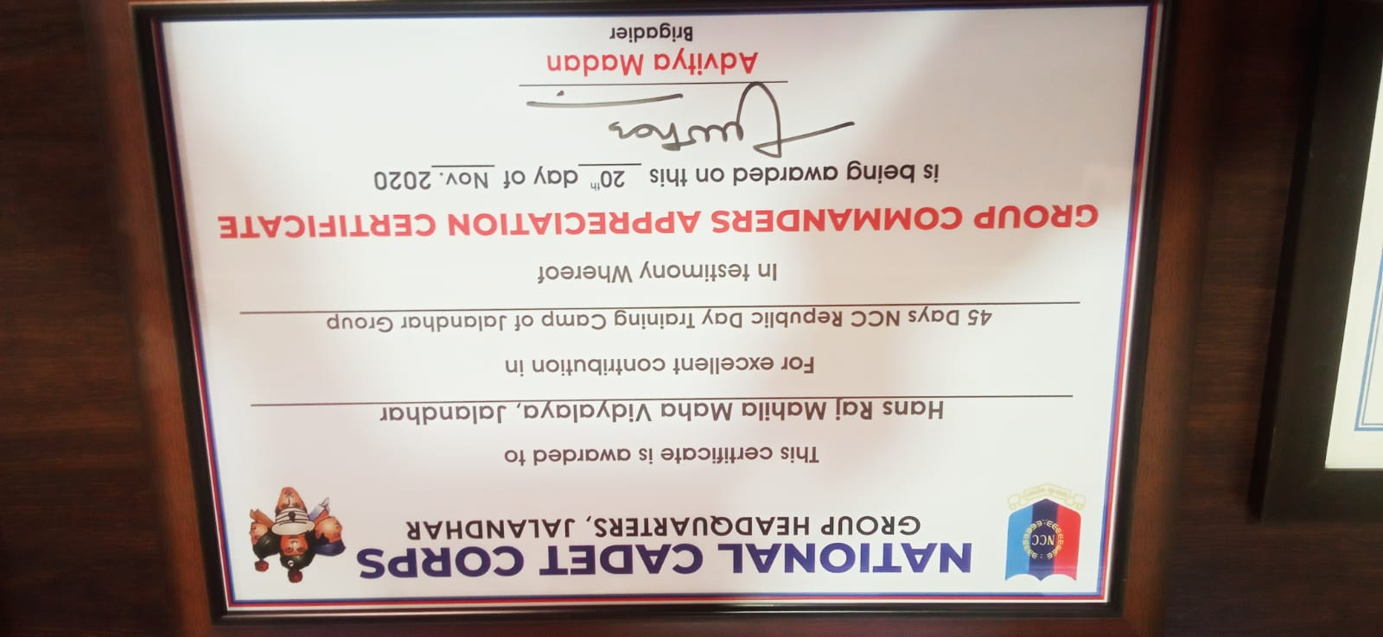
HMV WON 1ST RUNNER UP TROPHY IN IT PLASMA 2020 | Hans Raj Mahila Maha Vidyalaya won the 1st Runner up trophy in IT Plasma 2020 held at Lyallpur Khalsa College, Jalandhar. Total 47 students participated in 20 events with highest participation of 63 in all the events. Students have won many prizes along with Rs. 5500/- cash prize for all the first position holders. Principal Prof. Dr. Mrs. Ajay Sareen congratulated the winners. She told that the students won 1st prize in Ad Mad show, Hands on Keyboard, IT Snapshot, IT Extempore and IT Colors. The students won 2nd position in Logo designing, Test your Technical Skills, Query Maestro an IT in Colors. The students won 3rd position in Software showcase and Net Savvy. On this occasion, Head of Computer Science department Dr. Sangeeta Arora, Lt. Sonia Mahendru, Mr. Ashish Chadha, Ms. Sakshi and Ms. Shabnam were also present | 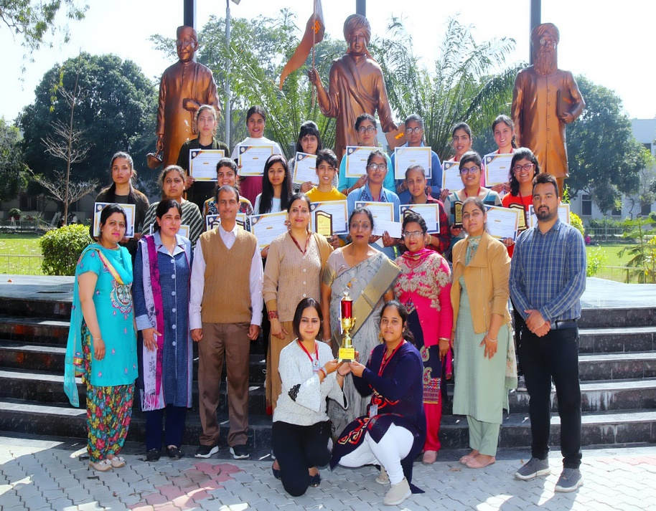
HANS RAJ MAHILA MAHA VIDYALAYA AWARDED BY MINISTRY OF EDUCATION GOVT. OF INDIA FOR BEAT COVID CAMPAIGN | Adding another feather to its golden cap, HMV Jalandhar received Appreciation Award for its excellent contribution in BEAT COVID Campaign of MGNCRE, MOE, Govt. of India. Principal Prof. Dr. (Mrs.) Ajay Sareen received the award from ADC (Development) Sh. Amarjeet Bains, PCS . On this occasion Principal Dr. Ajay Sareen said that HMV has always been engaged in community enrichment programmes with full zeal and enthusiasm. Programme Coordinator Dr. Anjana Bhatia said that students of Hans Raj Mahila Maha Vidyalaya, Jalandhar participated in different campaigns pertaining to the awareness of Covid-19. They formed various teams like Hospital Management team, Emotional Support team, Medicine team etc. and worked on the mission of Each One Reach One to beat COVID. Students imparted valuable information of this pandemic through the medium of social media. Volunteers of the college enlivened themselves to assist Covid affected people | 